TENSORBOARD SCREENS

1. SCALARS TAB

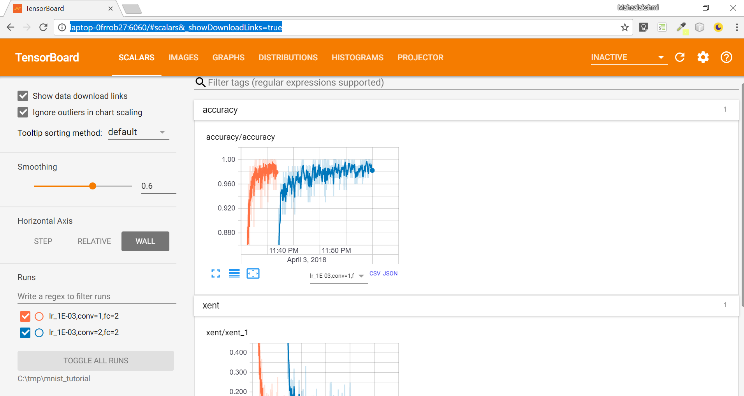

For further details on above screen tab, refer <https://www.tensorflow.org/programmers_guide/graph_viz>

1. IMAGES TAB

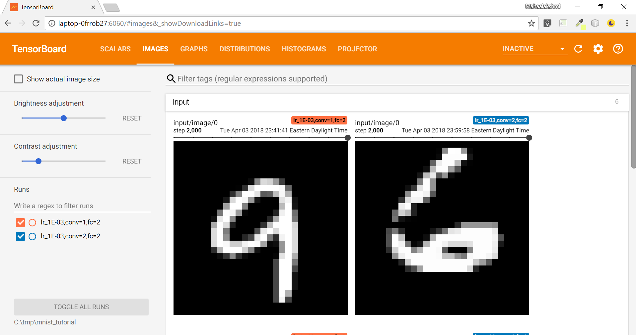

For further details on above screen tab, refer <https://www.tensorflow.org/api_guides/python/image>

C) GRAPHS TAB

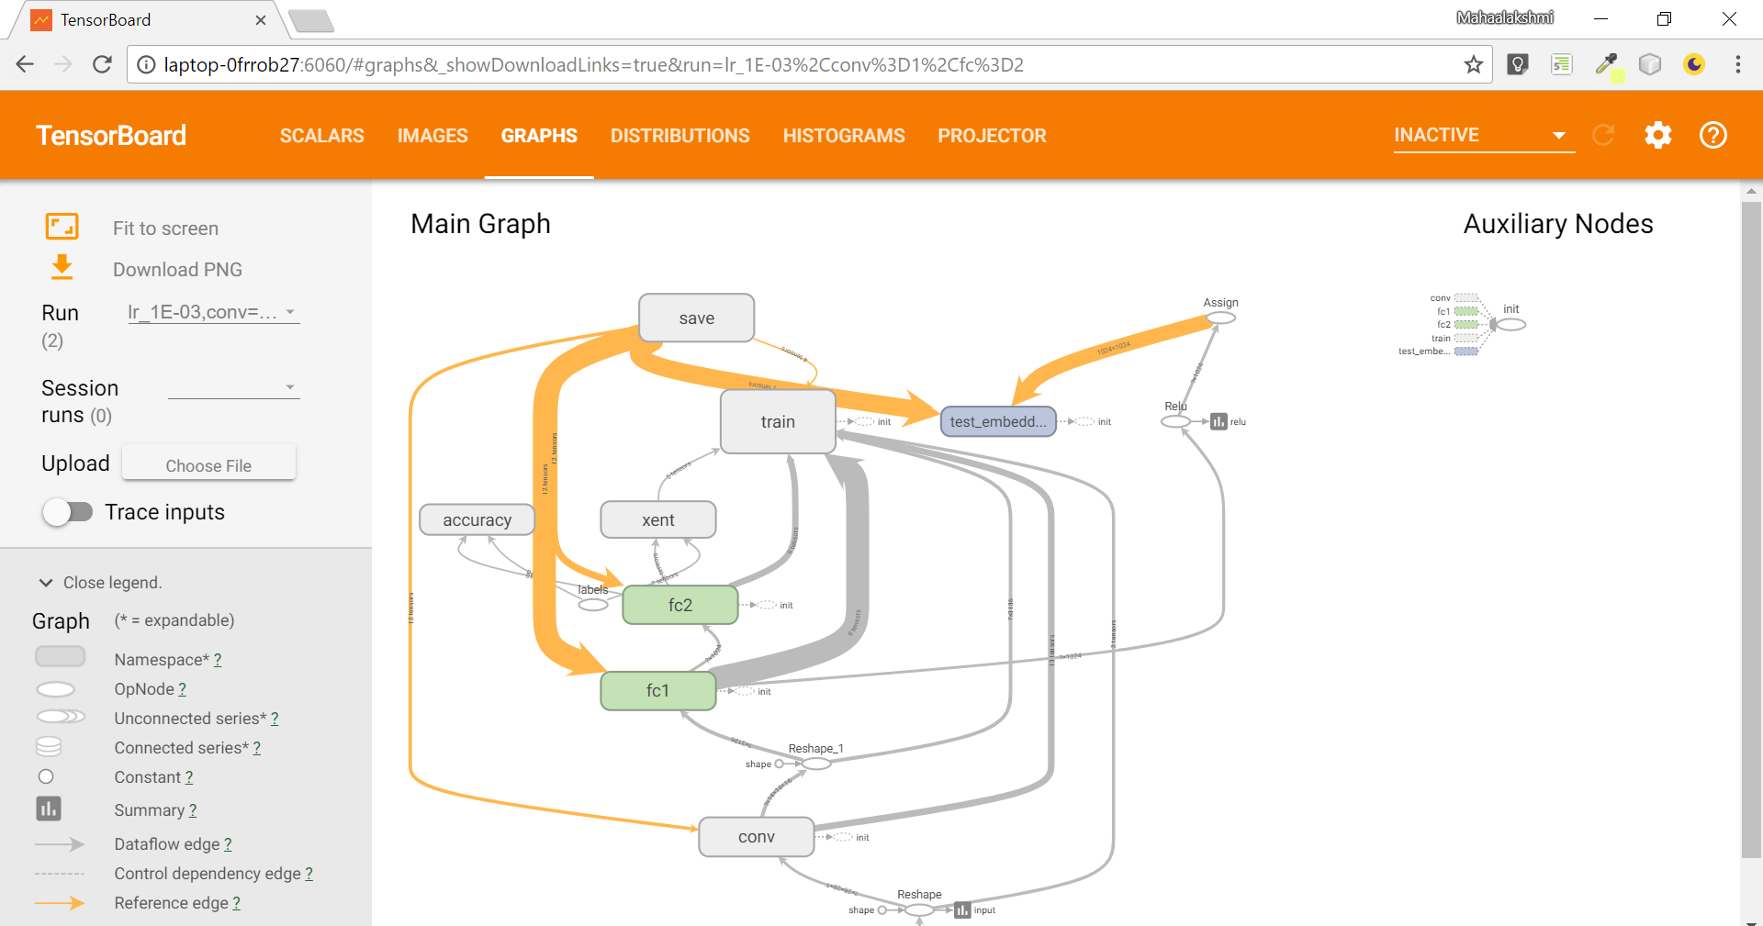

For further details on above screen tab, refer <https://www.tensorflow.org/programmers_guide/graph_viz>

D) DISTRIBUTIONS TAB

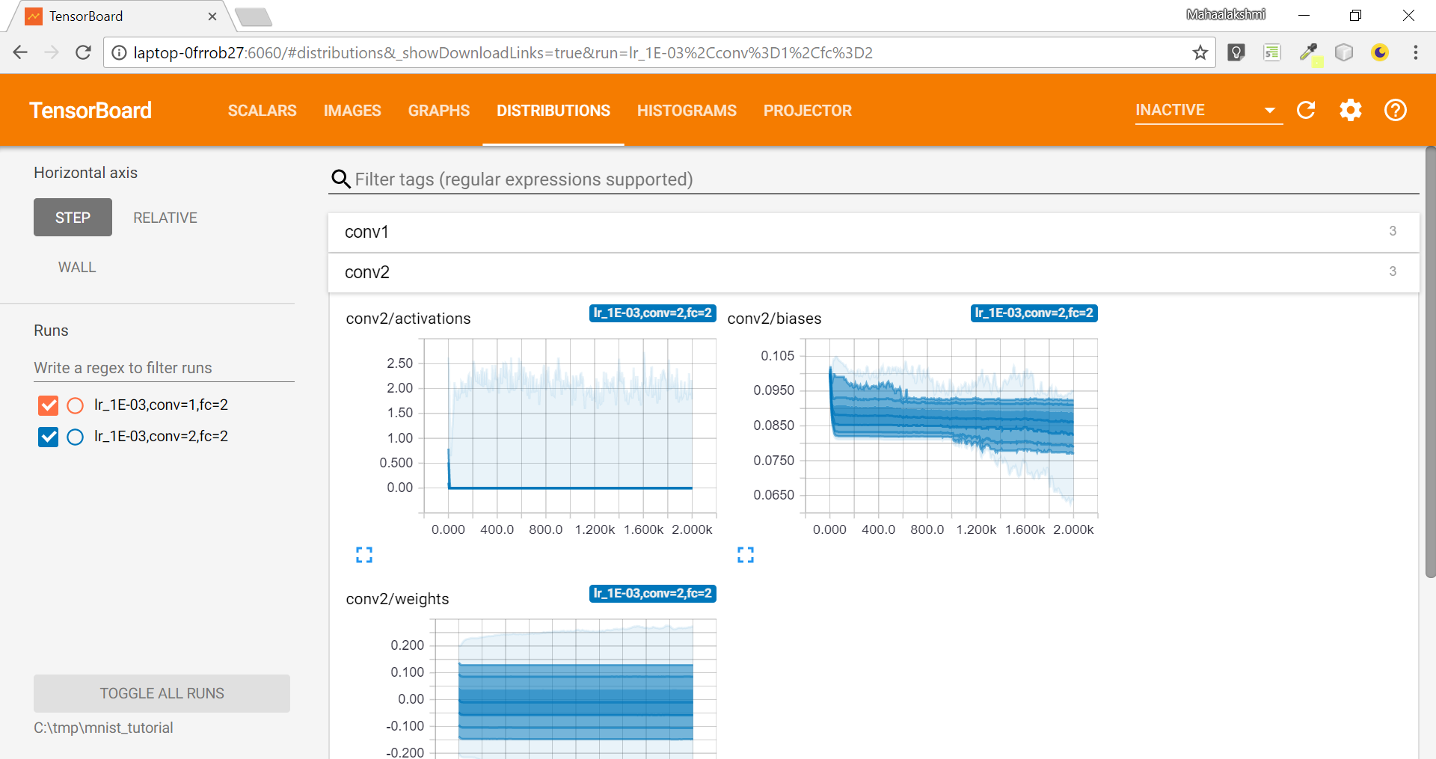

E) HISTOGRAMS TAB

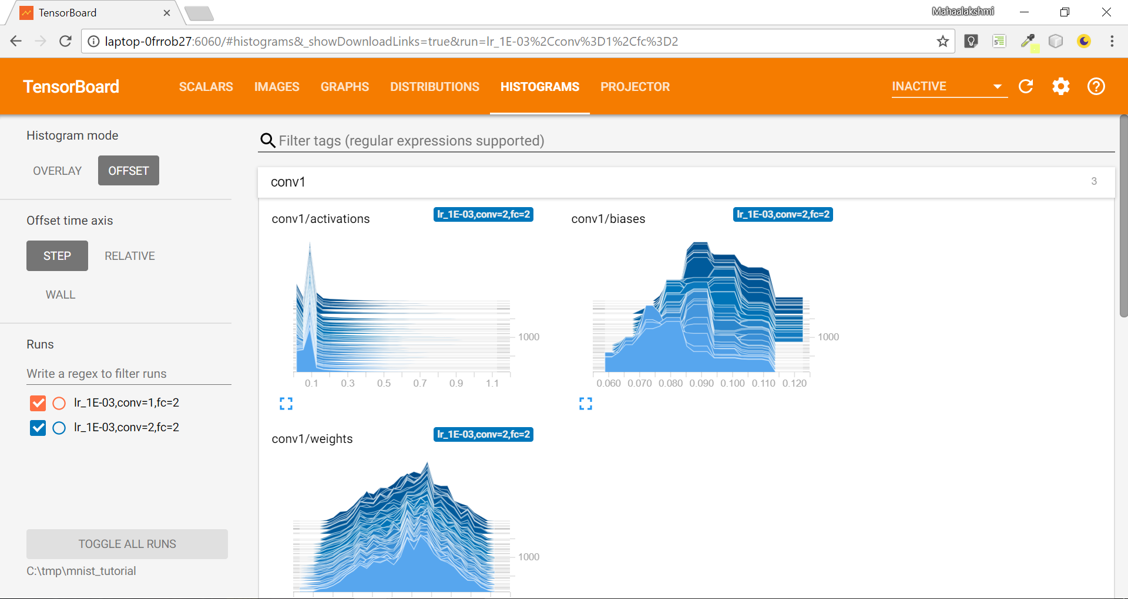

For further details on above screen tab, refer <https://www.tensorflow.org/programmers_guide/tensorboard_histograms>

F) PROJECTOR TAB

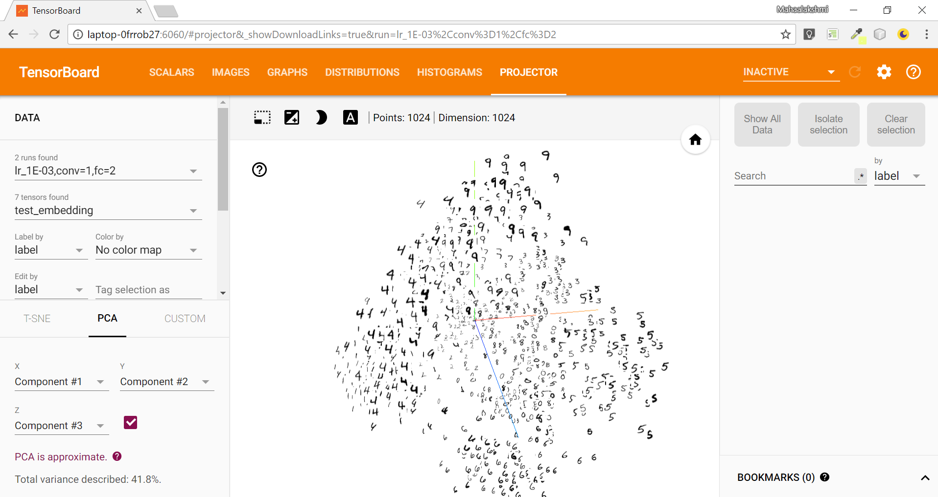

For further details on above screen tab, refer https://www.tensorflow.org/versions/r1.1/get_started/embedding_viz